# FLIPPED CLASSROOM

Flipped classroom is a pedagogical approach in which traditional content delivery moves to an ***individual learning process***, and the group activity is transformed into a dynamic, interactive learning environment where the instructor just guides the learners to apply their creative thinking to provide a fruitful solution in the course content. It provides more benefits than traditional direct content delivery.

# Benefits of flipped classroom

* + - * It promotes peer interaction among students and ***collaboration skills***
      * It encourages bright students’ engagement.
      * It provides increased individual attention.
      * It makes ***independent learning*** rather than teaching.

# Procedure:

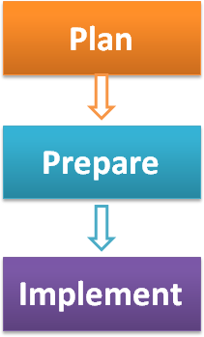

**Figure 1: Steps of Flipped Classroom**

***Plan***

* + - * + Identify the topic for ***independent study***.
        + Write the ***objectives*** of the flipped class
        + Create the ***schedules*** for a flipped class that contains the dates for posting material, class activity, and quiz. – Select the dates before holiday or exam.

***Prepare***

* + - * + Create an assessment (formative/summative) for each activity
        + Identify existing recorded video from MOOCs (NPTEL/MIT etc.) and text materials or create a video lecture or
        + Write the guidelines for learning from the video

***Implement***

* + - * + Form a small group. A group may be heterogeneous or homogeneous based on the students’ performance.
        + Upload the learning materials such as video and text documents on the course website
        + Give enough time(minimum 3 to 5 days) for students to study
        + Post a quiz to find whether the students understood the study materials or not and address the gaps before in class activity.
        + Design an application-oriented problem or project or case study for a class activity
        + Monitor the class activity to ensure that each group is actively involved to provide the solutions.
        + Make the group presentation for providing solutions.

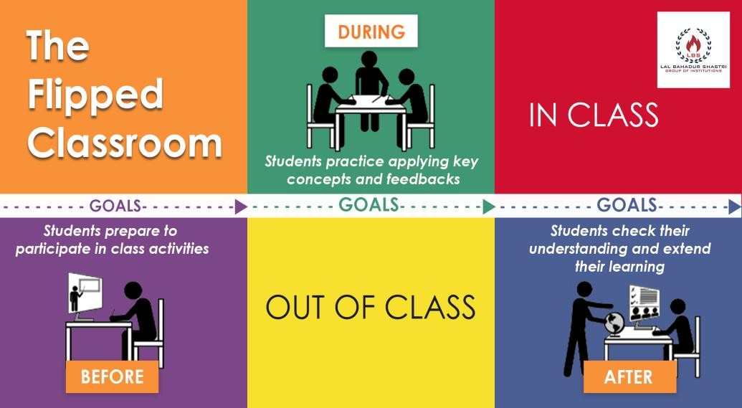

# (Credit: Google Image)

Students can watch the online lectures or read suggested study material (before class) and complete problem sets & preparing for quizzes/ exams (after class)[1]

# Ground Rule

* + - Learning materials such as NPTEL Video on Web service and its application uploaded on the course website.
    - Open to suggestions, sensitive feelings and concerns
    - Each activity such as online quiz, discussion and group presentation contains separate assessment and evaluation criteria.
    - Final score of a team will be calculated as the sum of individual score and team score.
    - Plagiarism is not allowed. If found, the student would be given zero to particular assessment.

# Concept teaching/Video lecture

A ***Class poll activity*** was conducted in the mid of the lecture to alert the lack of student’s attention. The students were asked to list the key service-oriented principles such as web services, Orchestration, reusability, operations etc. A ***video lecture*** was created

Or ***NPTEL video lecture*** was uploaded on Google Drive and shared with students.

The other study materials also posted on the course website one week before the commencement of in-class activity.

# 4.7. Justification to form a group

A heterogeneous group with six members was formed. Each group formed by bright students, average students, and slow learners. Classification of students such as ***a bright student, average students, and slow learners*** is based on their academic performance.

# Schedule of flipped class

|  |  |  |  |  |  |
| --- | --- | --- | --- | --- | --- |
| **Week end Friday** | **Before class At home Holidays** | **During the class at home** | | | **In class** |
| **Monday** | **Wednesday** | **Thursday** |
| Study material | Watch video | Review | Online Quiz | Discussion | Brainstorming |
| to be posted in |  | material | 15 minutes | Board | /Presentation |
| the course web |  | Discussion |  | (Educator | 50 minutes |
| site |  |  |  | address the gap) | Venue: CSE |
|  |  |  |  |  | Seminar Hall |

* 1. **Flipped class activities and assessments**

Activities in Flipped class collaborative learning that is listed below.

# Discussion

* + 1. **Quiz**

# Brainstorming/Presentation

# Evaluation of Individual and Group Performance

Students’ performances were evaluated using formative and summative assessment techniques. It is an effective tool to evaluate the various skills of the students.

## Assessment 1: Discussion

The objectives of the discussion are to encourage ***peer learning, critical thinking, and reflection***. I gave a discussion topic on the “Business Automation Process”. Based on the concepts of teaching and reading materials, students able to post their ideas and respond to the post of at least one of their friends. The following evaluation criterion was used for discussion to assess the students’ performance.

# Assessment 2: Online Quiz.

It carries 15 marks. It contains 15 multiple choice type questions from the study resources. The objective of an online quiz is to get students understanding level during the activity. The result used to address the gaps.

# Assessment 3: Brainstorming (BS)

The goal of the Brainstorming method is used to develop ideas by students. ***Students can freely propose their new ideas in their peer group***. Team members form a circle and discuss their ideas. Simultaneously, the performances of the students were assessed during the constructive discussion and were evaluated the solution of individual students using the following evaluation criteria. The students’ performance was assessed individually and group with ***individual formative assessment and Group summative assessment***, respectively. The group summative assessment follows the analytic rubric for evaluation. Through this, students should be able to develop various skills like ***leadership, interpersonal skill and team, and time management skill.***

***Individual formative Assessment-* Brainstorming**

* + - * Constructive idea /subject knowledge
      * Individual Role of his/her sub-task
      * Communication skill
      * Body language

The following rubric used for the presentation.

|  |  |  |  |  |  |  |  |
| --- | --- | --- | --- | --- | --- | --- | --- |
| **Evaluation criteria** | **Excellent**  **5.0 to >3.0 pts** | | **Good**  **3.0 to >2.0 pts** | | **Satisfaction**  **2.0 to >1.0 pts** | | **Marks** |
| Objectives | Presented objectives. | clear | Presented that relevant concepts. | objectives somewhat to the | Presented objectives. | wrong | 5 |
| Constructive Idea | Excellent idea with evidence and relevant content to demonstrate the problem. | | Little relevant content to demonstrate the problem. | | No relevant content to demonstrate the problem. | | 5 |
| Solution | Delivered the solution and content  professionally and answered the quires | | Delivered contents answered quires. | the and  the few | Delivered the contents and not answered the quires. | | 5 |
| Total | | | | | | | 15 |

# Feedback questionnaires for Flipped classroom

The feedback questionnaires were posted on the Canvas Course website after the completion of all activities. The feedback was collected from the students using the following questionnaires. It is used to assess the success of the Flipped Classroom. The first question is used to assess the ***student's willingness*** whether the students are like this activity or not. The second and third questions measure the ***objectives and outcomes of this activity***. The fourth question asks the students ***comments to improve the learning strategies.***

**FEEDBACK**

1. I like Flipped Classroom learning activity

Yes No

1. The Flipped classroom gives me greater opportunities to enhance my interpersonal skills like communication, listening, team work and leadership.

Strongly Agree Agree Disagree

1. Flipped Classroom will help me in my future education

Yes No

1. Any other comments

**-------------------------------------------------------------------------------------------------**

**------------------------------------------------------------------------------------------------**

# Reflection critique

## Challenges

* + - Recording video lecture and delivering content in front of the camera is challenging.
    - Recording Quality video and getting the quality device.
    - Deadlock situation may happen during an in-class activity like brainstorming

## Steps to be taken to avoid the problem.

* + - After recording a video with the help of my colleague, I gave it to peer-review to get both positive and negative suggestions/feedback from my peers. Based on their suggestion, I prepared a quality short video lecture.
    - The Presentation (PPT) is integrated with video using effective software like Camtasia studio.
    - Tips were given to motivate the students during the participation of in-class activity

## Post Implementation

1. Based on the observation, a lot of ***incidental learning*** happening in the discussion forum. They observed and learned a few things individually that lead to self-learning. They ***actively involved*** in this session rather than it being a one-way communication.
2. All the groups performed well in the group presentation session. This session

***re-enforced their understanding***.

1. Always, all the students took the ***quiz with joyfulness***.
2. Slow learners from two groups were not comfortable in their presentation due to lack of attention. However, they understood the concepts by these learning methods.
3. Learning at home automatically becomes ***student-centric*** rather than teacher-centric

**Conclusions**

The selected topic is playing a vital role in the industry to develop a business automation model. The flipped classroom technique is used to assess the students’ performance in continuous progress. This collaborative learning consists of three assessments such as ***Graded Discussion, Online Quiz, and Group presentation*.** The student’s performance was assessed by formative and summative evaluation tools to achieve objectives and outcomes. Based on the feedback analysis of the Flipped classroom learning technique and observation, the students could be able to enrich various skills such as ***communication, cooperation, and leadership***.